Script-Controlled ACL - Restrict Record Access Based on Field Value
Project Documentation
Team Members | Shivanii P; Sheerin Farhath; Seshriya; Shalini; Shanthini
Platform | ServiceNow Administrator
Core Module | Institution Details (`u_institution_details`)
Security Mechanism | Access Control Lists (ACLs) with conditions and scripted logic
Implementation Evidence | 72-page ServiceNow screenshot evidence supplied by the team
Project purpose: restrict record access according to a record field value while allowing designated administrative or authorized-role access. The submitted implementation uses the Institution Details table, Branch-based conditions, read/write ACLs, and an advanced scripted condition to control access.
Documentation basis: The structure is adapted from the supplied Sample Project Documentation, while the implementation details and figures are based on the team’s ServiceNow screenshot evidence.

1. Project Description
The project, Script-Controlled ACL - Restrict Record Access Based on Field Value, demonstrates how ServiceNow Access Control Lists can be used to restrict access to records based on field-level or record-level conditions. The project creates an Institution Details table and protects its records using ACL rules. The submitted evidence shows the complete flow from table creation through ACL configuration and security-rule verification.

Problem Statement
In a shared ServiceNow table, different users may need different levels of access to records. A simple role-only permission can be too broad when access must also depend on a particular field value. The project addresses this requirement by combining ServiceNow ACL decision logic with a Branch condition and an advanced script so that access can be granted or denied according to the configured security policy.

Objectives
- Create a custom Institution Details table in ServiceNow.
- Configure required fields including Branch and user/reference-based fields.
- Provide Branch values for the records, including EEE, ECE and CSE.
- Create read and write ACL rules for the custom table.
- Use a Branch = EEE condition together with scripted access logic.
- Verify read and write security decisions using ServiceNow security-rule verification.

Project Scenario
For the demonstrated scenario, access to EEE records is restricted so that administrators retain access while the configured authorized role can access the relevant records. Other users are denied according to the script. A separate write ACL is configured with its own required role and verification.

2. Technical Architecture
The solution follows a ServiceNow platform-centric architecture. Users interact with the ServiceNow interface; the request reaches the platform’s security evaluation layer; ACL rules then evaluate role information, configured record/field conditions, and scripted logic before the platform returns an allow/deny decision.
USER / ADMIN | SERVICE NOW PLATFORM | ACCESS DECISION
User role / session | Institution Details table  `u_institution_details` | ALLOW / DENY
Requested operation  READ or WRITE | ACL evaluation  Role + Condition + Script | Record access  according to policy

Main Components
- Institution Details table: custom table named `u_institution_details`.
- Fields: Student Roll Number, Student Name, Faculty Name, Branch, Email, Phone Number, Description, plus standard system fields.
- Choice data: Branch options include EEE, ECE and CSE.
- ACLs: read and write rules configured for the custom table.
- Conditions: field-based logic such as Branch is EEE.
- Advanced script: programmatic allow/deny decision based on the current user’s role.
- Verification: ServiceNow Verify Security Rules screens show the resulting security decision.
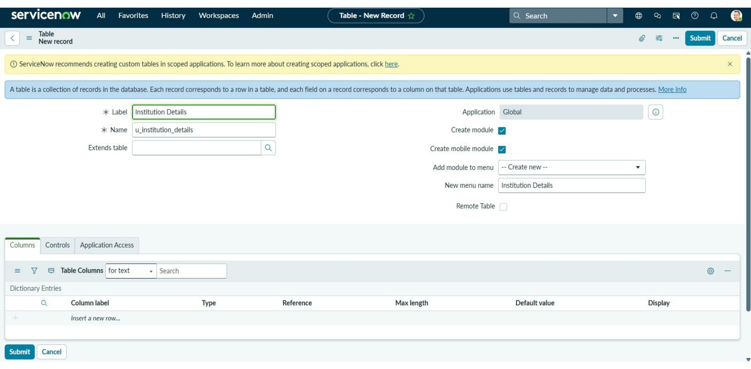
Figure 1. Custom Institution Details table configuration captured in ServiceNow.

3. Project Workflow
Phase | Activity | Output
1. Requirement | Identify need for field-value-based record restriction. | Security requirement
2. Data Model | Create `u_institution_details` and define fields. | Custom table + fields
3. Choice Data | Configure Branch values and create test records. | EEE / ECE / CSE records
4. Roles | Create/assign project-specific user roles for ACL evaluation. | Role-based access context
5. Read ACL | Configure read ACL with required role, Branch condition and script. | Controlled read access
6. Write ACL | Configure write ACL with required role and security conditions. | Controlled write access
7. Verification | Use Verify Security Rules for read and write operations. | Allow/deny verification evidence
8. Testing | Check configured behavior and capture screenshots. | Implementation evidence

4. Milestone 1 - Data Model and Table Creation
The first implementation milestone establishes the custom data structure. The evidence shows a new ServiceNow table named Institution Details with the internal name `u_institution_details`. The table is used as the protected resource for the subsequent ACL configuration.
Figure 2. Creation of the Institution Details table in ServiceNow.
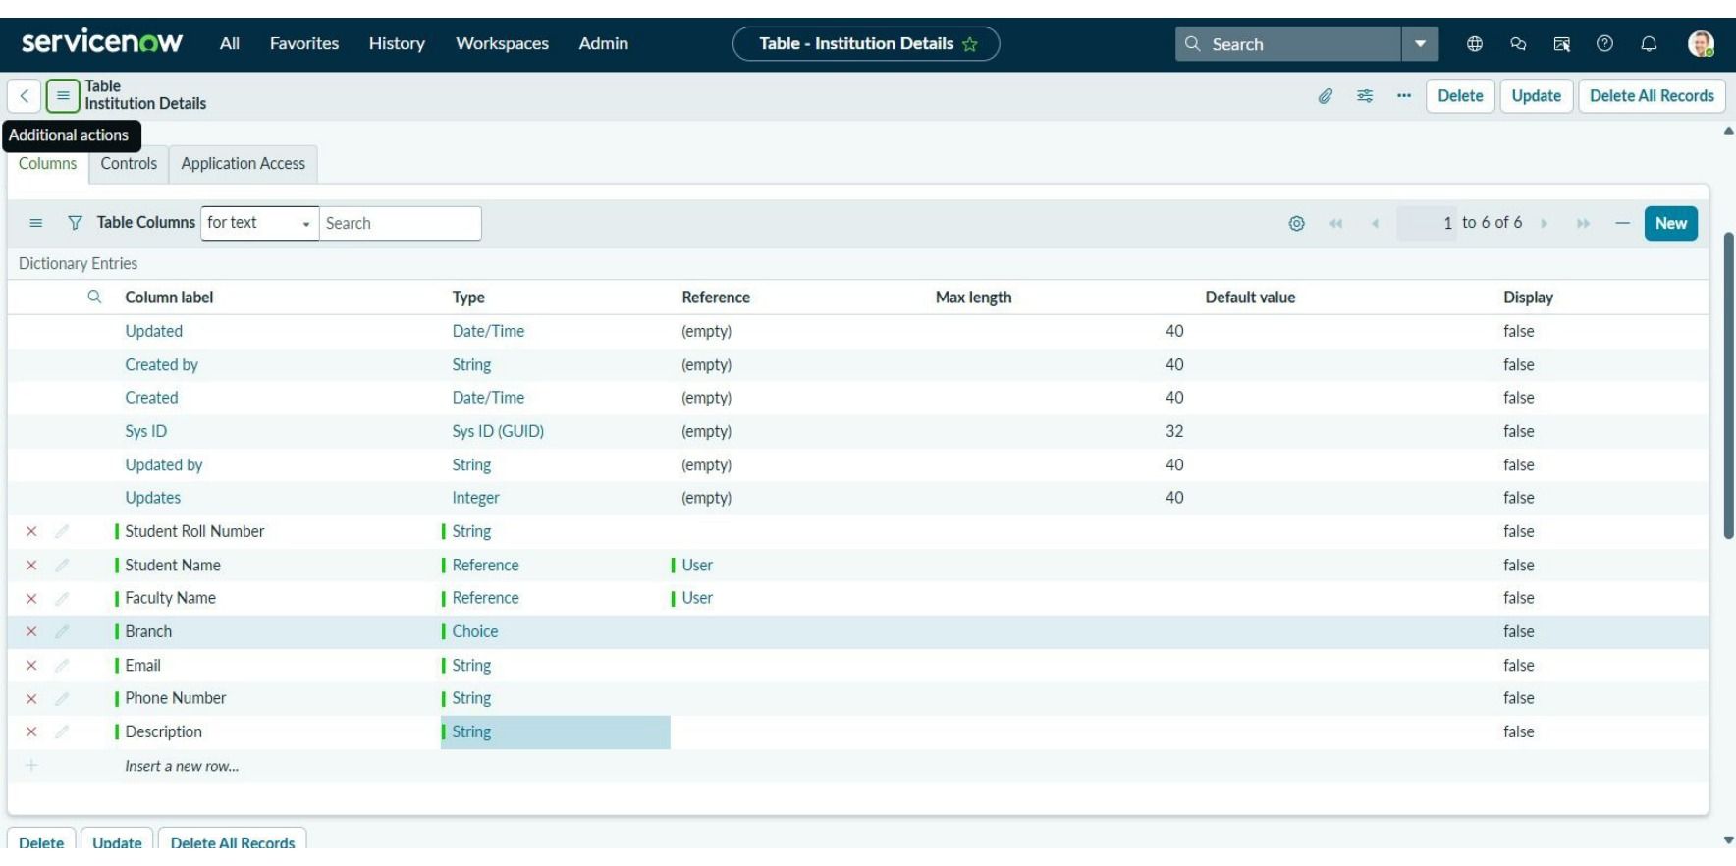
Figure 3. Institution Details fields configured in the custom table.

5. Milestone 2 - Choice Values and Sample Records
The project then configures the Branch field as a choice field. The submitted evidence shows selectable values including EEE, ECE and CSE. Sample Institution Details records are created so that the ACL behavior can be demonstrated against actual data.
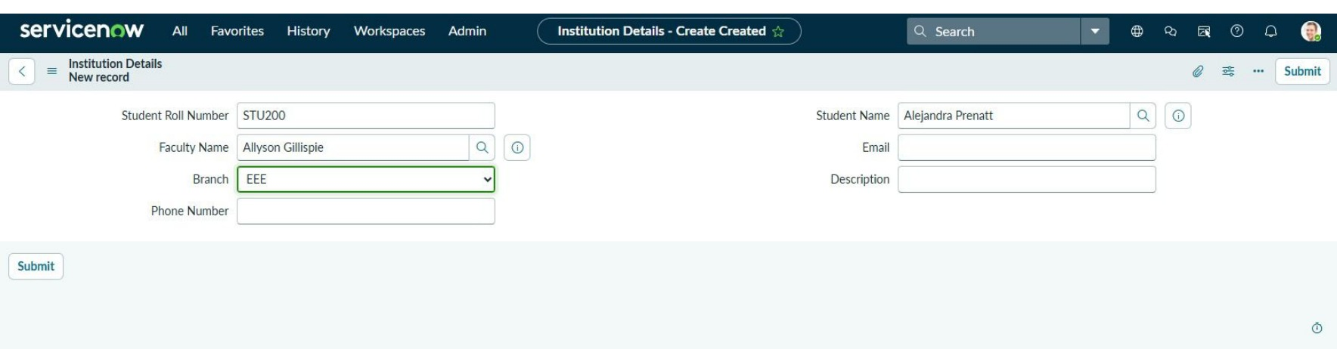
Figure 4. Institution Details record creation with Branch set to EEE.
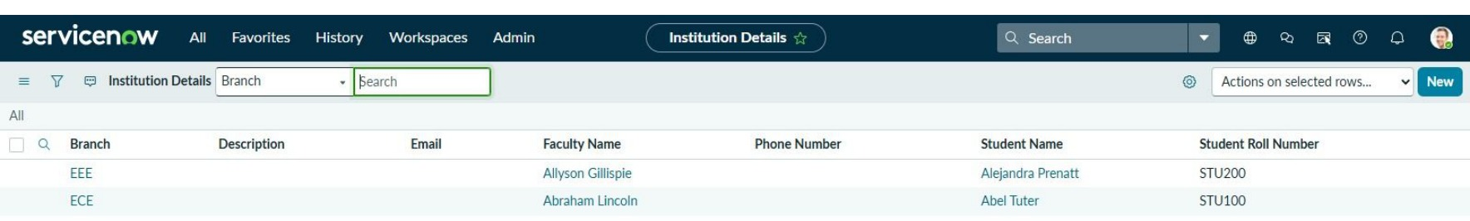
Figure 5. Institution Details list showing stored records and their Branch values.

6. Milestone 3 - Roles and Access Control
The implementation creates and manages users and roles so ACL rules can evaluate different access contexts. The evidence then moves to the Access Control list, where rules for the custom `u_institution_details` table are configured. The ACL form includes the operation, active state, decision type, required role, conditions, and an Advanced Condition script area.
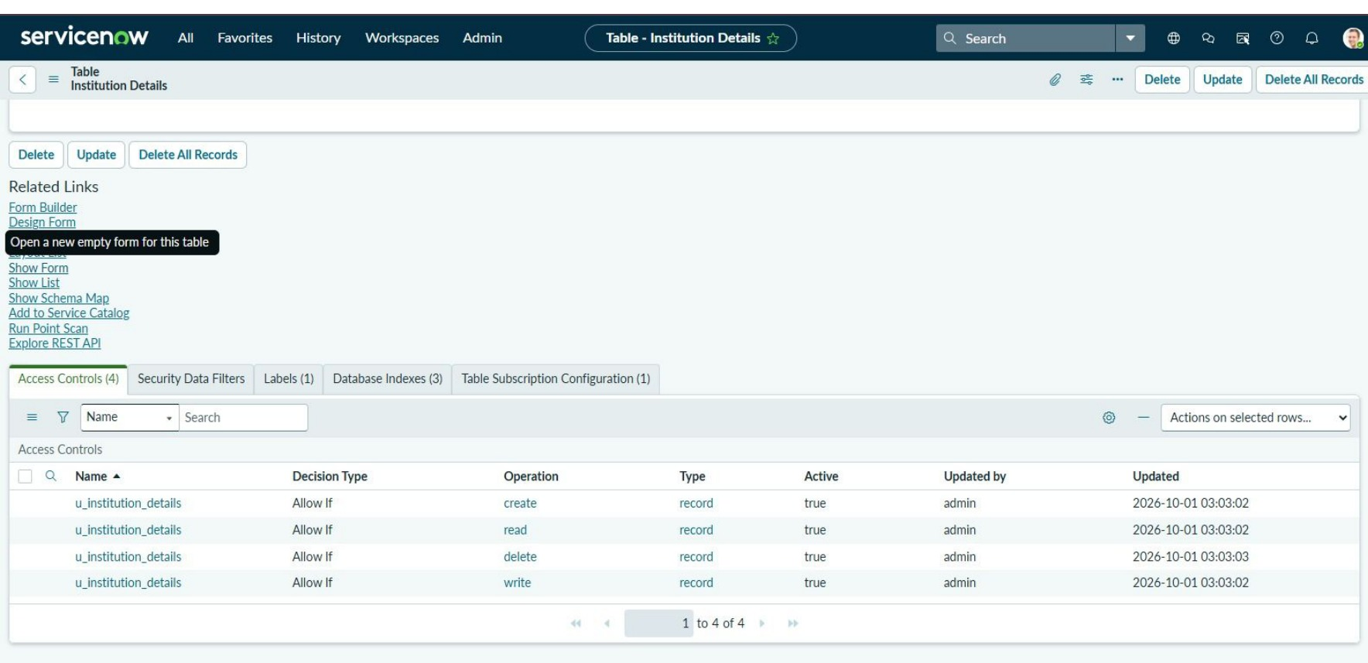
Figure 6. Access Control rules list in ServiceNow.
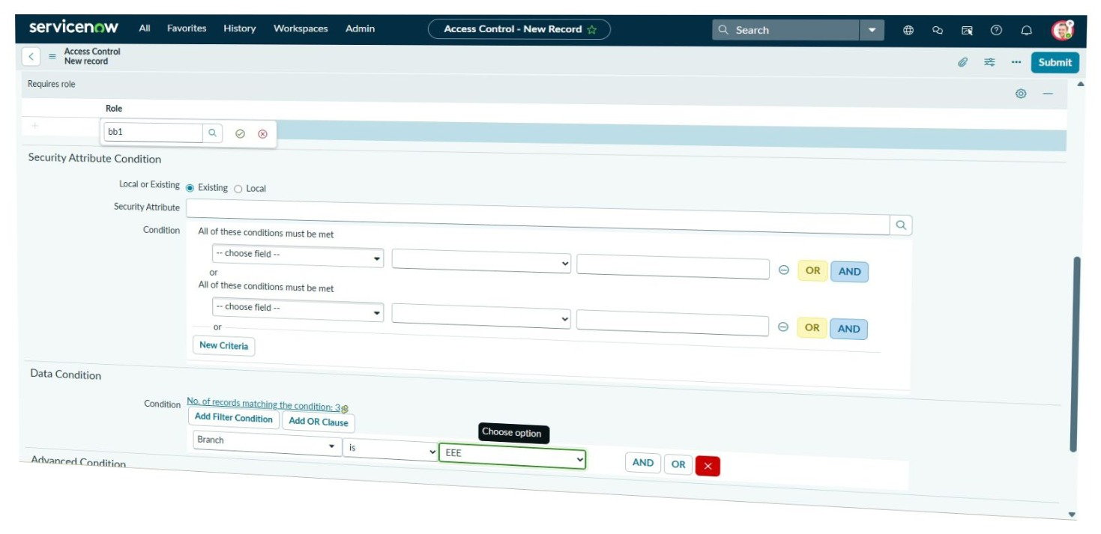
Figure 7. New Access Control rule form for the custom table.

7. Milestone 4 - Field-Value Condition and Script
The key implementation step is the combination of a field-level data condition and a scripted ACL decision. The submitted evidence shows Branch is EEE as the data condition. The Advanced Condition contains an ECMAScript function that explicitly allows administrators, allows the configured `bb1` role, and denies other users.
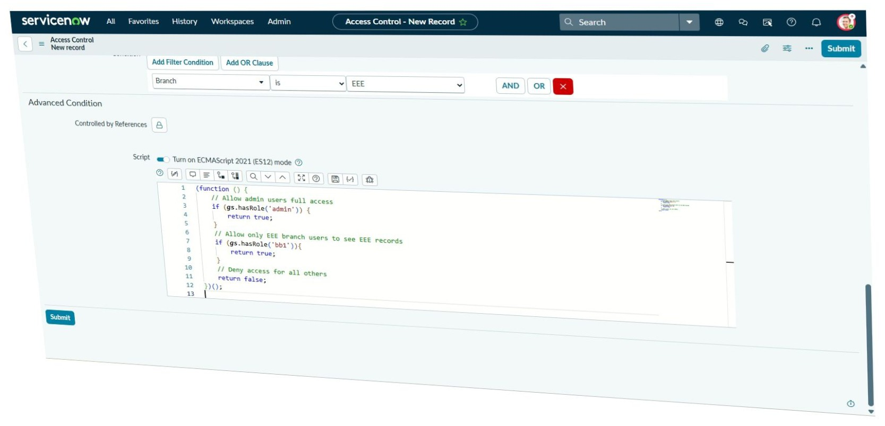
Figure 8. Branch = EEE condition and the advanced script used by the ACL.
Script logic represented in the submitted evidence:
(function () {
// Allow admin users full access
if (gs.hasRole('admin')) {
return true;
}
// Allow the configured role to access the tested records
if (gs.hasRole('bb1')) {
return true;
}
// Deny access for all others
return false;
})();

8. Milestone 5 - Read ACL Verification
After configuring the read ACL, ServiceNow’s security-rule verification is used to inspect the resulting decision. The submitted evidence shows a Read (Allow) result for `u_institution_details`, providing direct evidence that the configured rule is being evaluated in the demonstration context.
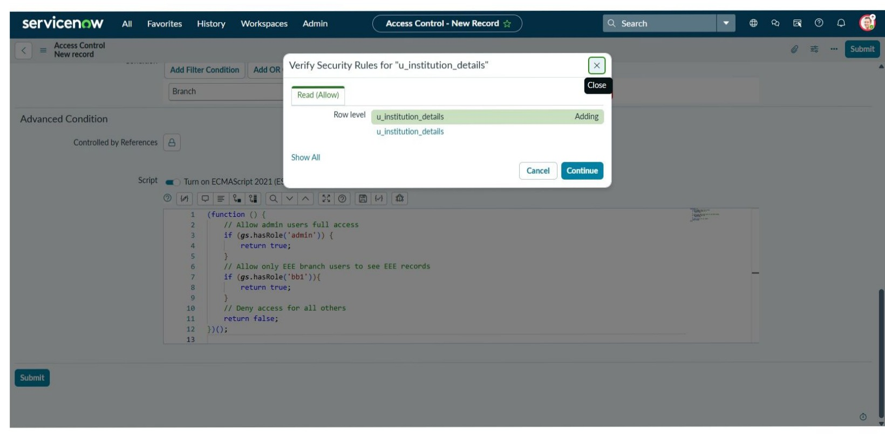
Figure 9. Scripted read ACL and its configuration.
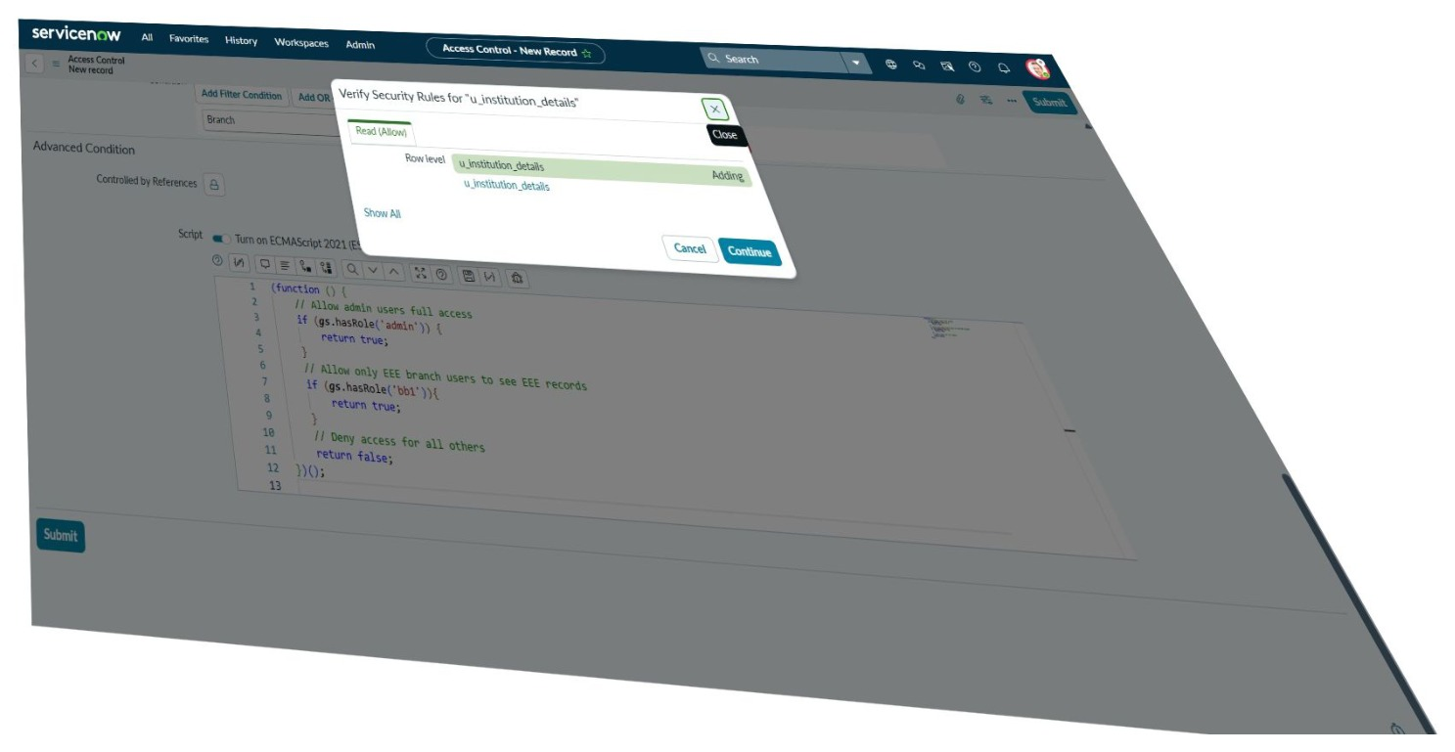
Figure 10. Verify Security Rules dialog showing Read (Allow).

9. Milestone 6 - Write ACL Configuration
A separate write ACL is configured to control modification access. The submitted evidence shows the Write operation, the `u_institution_details` resource, and a required role in the ACL conditions. This demonstrates that the project does not rely on a single permission for all operations; read and write access are controlled independently.
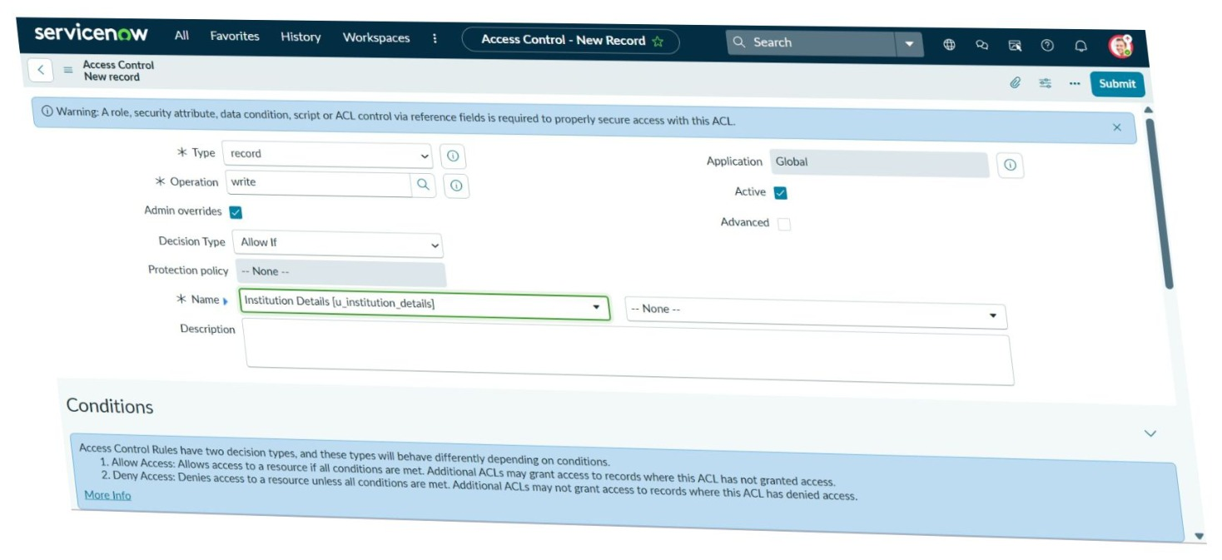
Figure 11. Write Access Control rule configuration.
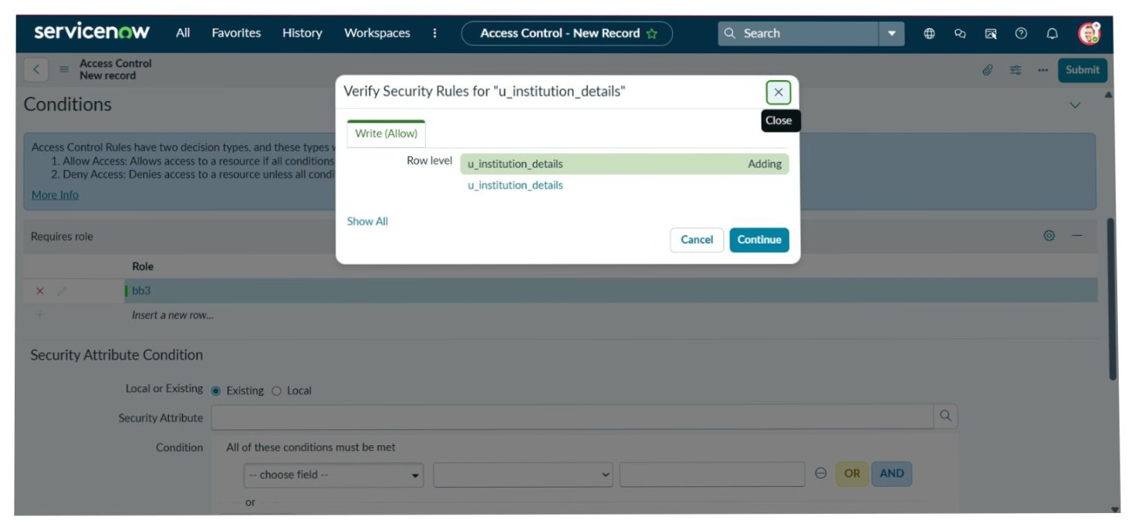
Figure 12. Verify Security Rules dialog showing Write (Allow) for the custom table.

10. Testing Strategy
Testing for this project is security/functional testing rather than conventional application load testing. The objective is to confirm that the ACL rules evaluate correctly for the intended operation, role, and record condition. Each test uses the ServiceNow interface and the built-in security-rule verification evidence.
ID | Test Area | Procedure | Expected Result
TC-01 | Table configuration | Open `u_institution_details` and confirm the custom fields exist. | Configuration is present.
TC-02 | Branch choices | Inspect Branch choice list. | EEE, ECE and CSE choices are available.
TC-03 | Read ACL setup | Inspect read ACL role, condition and script. | Expected read policy is configured.
TC-04 | Read verification | Run Verify Security Rules for the read rule. | Read (Allow) is shown for the configured context.
TC-05 | Write ACL setup | Inspect write operation and required role. | Expected write policy is configured.
TC-06 | Write verification | Run Verify Security Rules for the write rule. | Write (Allow) is shown for the configured context.
Performance testing note: The team’s supplied evidence does not include JMeter, Locust, k6, CPU/memory monitoring, or measured throughput. Therefore, numerical performance claims are not included in this project documentation.

11. Implementation Evidence Summary
Evidence | What it proves
Table creation | Custom `u_institution_details` table exists.
Field configuration | Institution Details fields are configured.
Branch choices | Branch values are configured for the test data.
Record creation | Test records are created in the table.
ACL configuration | Access Control rules exist for the custom table.
Branch = EEE condition | Record-level/field-value restriction is configured.
Advanced script | Role-aware allow/deny logic is configured.
Read verification | ServiceNow reports Read (Allow) for the tested rule.
Write verification | ServiceNow reports Write (Allow) for the tested rule.
Together, the screenshots show the complete implementation chain: data model -> test records -> roles -> ACL configuration -> Branch-based restriction -> scripted decision -> security-rule verification.

12. Limitations and Security Considerations
- The solution is tied to the roles and security configuration present in the ServiceNow instance.
- The document intentionally does not publish instance URLs or login credentials.
- ACL behavior should be re-verified whenever roles, table fields, or security rules are changed.
- The current evidence demonstrates a Branch = EEE scenario; additional field values can be supported by extending the ACL policy.
- No external load/performance testing was conducted in the supplied evidence.

Future Enhancements
- Add additional branch-specific ACL policies for other organizational groups.
- Introduce a more data-driven access mapping between user role and permitted Branch.
- Add a dedicated test matrix covering positive and negative role combinations.
- Capture formal performance measurements if a performance-testing requirement is introduced.
- Package the configuration as a managed ServiceNow application/update set for repeatable deployment.

Expected Benefits
- Reduces unauthorized access to sensitive records.
- Provides field-aware access control instead of relying only on broad roles.
- Makes the security policy visible and verifiable through ServiceNow ACL tooling.
- Separates read and write permissions so each operation can be controlled independently.

13. Conclusion
The project demonstrates a ServiceNow security design in which record access is restricted according to field value and user role. The custom `Institution Details` table acts as the protected resource, while ACL rules provide operation-specific control. The read policy combines the Branch = EEE condition with an advanced script that grants access to administrators and the configured `bb1` role while denying other users. A separate write ACL provides independent control over modification access.
The submitted screenshots provide implementation evidence for table creation, field configuration, record creation, ACL configuration, scripted logic, and both read and write security-rule verification. This makes the project suitable for a demonstration-focused ServiceNow security submission.

Team
Shivanii P | Sheerin Farhath | Seshriya | Shalini | Shanthini
Final implementation identifier: `u_institution_details`
Primary security scenario: Branch = EEE with scripted role-based access decision
Verification evidence: ServiceNow Verify Security Rules - Read (Allow) and Write (Allow)

